Sulaibikhat Inter. Religious Institute 5th Form 1st Term Remedial Work and Worksheet
Unit One (Vocabulary )
 | Words |  | Words
1 | heavyثقيل | 7 | carryيحـــمــــل
2 | mine ملكي | 8 | hooray!مرحــــــــــا
3 | universityجامعة | 9 | numberرقم - عدد
4 | modernحديث | 10 | coatمعطف
5 | Canadaكــــنــــدا | 11 | studyيدرس – يذاكر
6 | untilحتى
A) Underline the correct answers:-
1- This book isn’t yours. It’s ………………….
a- my b- mine c- myself d- him
2- I can't ………………………..this table. It's very heavy.
a- study b- wait c- carry d- build
3-…………………………..! Aunt Yasmeen will stay for a year.
a- Hooray b- Hurry c- Honey d- Money
4- We always …………………….our lessons very hard to get high marks.
a- carry b- buy c- wait d- study
5- We live in a ………………………and big villa near the sea,
a- modern b- small c- heavy d- sad
6- People in Canada always wear …………………..in winter.
a- numbers b- coats c- universities d- lettuces
7- She can’t carry the bag because it’s very…………………
a- sad b- modern c- old d- heavy
8- After finishing my school I will join the……………….
a- coat b- number c- university d- scarf
Grammar
B) Underline the right answers:-
10- Could you …………………………the door, please?
a- opened b- opens c- open d- opening
11- In the past, people ……………………..in old houses.
a- lived b- live c- living d- lives
12- Mum always ……………………food in the kitchen.
a- cook b- cooks c- cooked d- cooking
13- Next year we …………………in grade six.
a- will be b- be c- are d- is
14- I’d like to …………………a doctor in the future.
a- is b- are c- was d- be

Unit Two (Vocabulary )
 | Words |  | Words
1 | anything أي شيئ | 7 | sadحزين
2 | buyيشتري boughtإشترى | 8 | scarf حجــــاب - وشاح
3 | feelيشعر | 9 | but لكن
4 | lettuceخس | 10 | souq السوق
5 | Somethingشيئ ما | 11 | wait ينتظر
6 | restاستراحة | 12 | goldذهب
A) Underline the right answers:-
1- I’d like to eat green salad with…………………………
a- gold b- lettuce c- souq d- rest
2- My sister's necklace is made of ………………………..
a- rest b- coat c- scarf d- gold
3- I ……………………..happy when I get top marks in English.
a- feel b- wait c- carry d- buy
4- Do you need ………………………..to eat?
a- something b- someone c- anything d- some
5- He always ……………………the bus at the bus stop.
a- waits b- carries c- buys d- feels
6- Aunt Yasmeen wears a ………………….on her head.
a- souq b- scarf c- rest d- number
7- Yesterday, she …………………..a new dress.
a- carried b- waited c- bought d- studied
8- My Mum went to the …………………to buy a bag and shoes.
a- coat b- souq c- number d- rest
9- Hamad is very …………………..because his brother is very ill.
a- happy b- modern c- fat d- sad
10- When I'm tired I'll have some………………….
a- souq b- rest c- coat d- gold
Grammar
B) Underline the right words:-
11- I haven't got …………………………in my hand now.
a- something b- anything c- nothing d- someone
12- What are you ……………….to do this evening?
a- go b- goes c- gone d- going
13- He didn’t …………………..me the truth.
a- tells b- told c- telling d- tell
14- She has …………………..in her bag.
a- something b- someone c- anything d- some
15- Majid likes football ………………….he doesn’t like tennis.
a- and b- or c- but d- so
16- Last Friday, I …………………..a new jacket.
a- bought b- buy c- buys d- will buy
Unit Three ( Vocabulary )
 | Words |  | Words
1 | back الخلف | 11 | endينهي – نهاية
2 | build يبني builtبنى | 12 | insideداخل
3 | darkمظلم | 13 | paraffin lamp سراج – مصباح زيتي
4 | dining room غرفة الطعام | 14 | oldقديم
5 | downstairsأسفل | 15 | stairsدرج – سلالم
6 | electricityكهرباء | 16 | studyدراسة
7 | front أمام | 17 | Upstairsالدور العلوي
8 | hallصالة | 18 | yardساحة
9 | roofسطح | 19 | sleep ينام – slept نام
10 | sitيجلس satجلس | 20 | outsideخارج
- Underline the correct words:-
1- Children should sit at the ……………………..of the car.
a- front b- next c- back d- behind
2- People used ………………… to lighten the houses in the past.
a- paraffin lamps b- stairs c- yards d- halls
3- We eat in the ……………………………at home.
a- bedroom b- bathroom c- sitting room d- dining room
4- I can’t see anything. It’s …………………..in here.
a- sad b- dark c- light d- hot
5- People used to sleep on the …………………on hot nights in the past.
a- roof b- bathroom c- lamps d- gold
6- Children always play in the …………………in front of the house.
a- roof b- upstairs c- yard d- stairs
7- There wasn’t ………………so people used paraffin lamps.
a- stairs b- hall c- roof d- electricity
8- Aunt Yasmeen’s room is ……………………..so she goes up.
a- downstairs b- outside c- inside d- upstairs
9- We always watch TV in the………………………….
a- hall b- bathroom c- kitchen d- stairs
10- I have a lot of pens and pencils…………………..my pen case.
a- upstairs b- inside c- downstairs d- upstairs
11- I always park my car in …………………….of my house.
a- back b- front c- behind d- next
Grammar
B) Underline the right answers:-
12- Would you like to ………………….some apples?
a- eats b- eat c- eating d- ate
13- In the past, people ………………………paraffin lamps.
a- have b- has c- having d- had
14- A long time ago, people ……………………. on the roof.
a- sleeps b- sleep c- slept d- will sleep
15- The pupils ……………………English now.
a- are studying b- study c- studied d- studies
16- Look! The boy is ……………………very fast.
a- run b- runs c- running d- ran
17- People ………………….old houses in the past.
a- build b- building c- built d- will build
18- I can see some boys ………………….the back of my house.
a- at b- in c- of d- on

Unit Four ( Vocabulary )
 | Words |  | Words
1 | bothكلاً من | 9 | mobile phoneنقال - جوال
2 | Canadianكندي | 10 | poorفقير – ضعيف - مسكين
3 | clearيزيل – ينظف – يمسح | 11 | put on يلبس- يرتدي
4 | dangerousخطير | 12 | roadطريق
5 | get outيخرج | 13 | snowثلج – يثلج
6 | icyجليدي | 14 | snowstormعاصفة ثلجية
7 | knee ركبة | 15 | truck شاحنة
8 | late متأخر
A)Underline the correct words from a, b, c or d:-
1- It’s ……………….to drive in a snowstorm.
a-happy b- dangerous c- poor d- dark
2- Roads are ………………in Canada in winter.
a-clear b-sad c- poor d- icy
3- In cold weather people…………….coats and scarves.
a-put on b- get out c- clear d- snow
4- Drivers mustn’t use the…………..while driving.
a-truck b- knee c- mobile phone d- road
5- The...................clears the ice from the road.
a-knee b- snow c- road d- truck
6- Poor grandpa! He was caught in a snowstorm and couldn’t......................
a-get out b- put on c- snow d- study
Grammar
B)Underline the right answers from a, b, c or d:-
7- What is the weather......................in Kuwait in summer?
a-likes b- like c- liked d- liking
8- There....................a snowstorm in Canada last winter.
a-is b- are c- was d- were
9- The bag was too heavy so I....................carry it.
a-couldn’t b- could c- have to d- should
10- Last night, I......................take a taxi because it was raining heavily.
a-have to b- has to c- can d- had to
11- It........................in Canada every winter.
a-snowed b- snows c- will snow d- snowing
12- The baby..........................now.
a-cries b- cried c- is crying d- will cry
13- In a snow storm you........................wait in the car.
a-should b- could c- shouldn’t d- couldn’t
14- They........................to the farm yesterday.
a-drive b- drives c- will drive d- drove

Unit Five ( Vocabulary )
 | Words |  | Words
1 | dustتراب | 7 | car brakeكابح السيارة
2 | dust stormعاصفة ترابية | 8 | car light ضوء السيارة
3 | everyoneكل واحد | 9 | turn on يضيء
4 | might be ربما | 10 | clothقطعة قماش
5 | uncomfortable مريح غير | 11 | suddenlyفجأةً
6 | hurry يسرع Hurry up إسرع | 12 | snowyجليدي - ثلجي
A)Underline the correct words from a, b, c or d:-
1- We can see a lot of…………………..in a dust storm.
a- water b- snow c- dust d- ice
2- .....................! We are very late for school.
a- Hurry up b- Put on c- Turn on d- Turn off
3- Dust storm is very………………..because dust go into your nose.
a- comfortable b- poor c- modern d- uncomfortable
4- I was studying,…………………..the lights went off.
a- beautifully b- suddenly c- really d- truly
5- Drivers should……………… the car lights in a dust storm.
a- turn on b- turn off c- get out d- put on
6- To sop the car you must put on the…………………
a- car light b- car park c- car brake d- car door
Grammar
B) Underline the right answers:-
7- You might………………..dust in your nose or eyes.
a-got b- gets c- getting d- get
8- If you are in a dust storm, you…………………stop the car.
a-are b- should c- were d- is
9- Drivers in Kuwait………………..drive on the right.
a-must b- had to c- mustn’t d- has to
10- ………………….the door, please.
a-Closing b- Closed c- Close d- Closes
11- If you walking outside, you should………………..your nose.
a-cover b- covering c- covered d- covers
12- The sun…………….in the east.
a-rise b- will rise c- rose d- rises
Unit Six ( Vocabulary )
 | Words |  | Words
1 | book fair معرض كتاب | 7 | tooأكثر من اللازم
2 | kindنوع | 8 | writer كاتب
3 | difficult صعب | 9 | scary مخيف
4 | easyسهل | 10 | think يفكر يعتقد –
5 | enoughكافي - بدرجة كافية | 11 | choose يختار
6 | storybookقصة | 12 | information معلومات
 |  | 13 | usefulمفيد
A) Underline the correct words from a, b , c or d:-
1-When you read books you get lot of………………………
a-writer b- information c- ice d- light
2- We can buy books, magazines and cartoons at the……………………
a-book fair b- gold shop c- coffee shop d- fish market
3- Our English test was very…………………so I've got full marks.
a-sad b- difficult c- dangerous d- easy
4- I don’t like reading ……………………books. They are frightened.
a-funny b- interesting c- scary d- easy
5- I bought a lot of storybooks. You can……………….one of them.
a-choose b- think c- wait d- snow
6- Abdel Aziz Hussein is a famous Kuwaiti……………He wrote a lot of books.
a-farmer b- driver c- writer d- fireman
7- Reading is a very………………hobby.
a-dangerous b- useful c- icy d-scary
Grammar
B) Underline the right answers from a, b, c or d:-
8- That question is too easy for me. It's not difficult ………………………
a- too b- to c- enough d- very
9- This film is ……………….boring. It's not interesting enough.
a-enough b- too c- to d- that
10- We ………………to Bahrain last week.
a- go b- going c- will go d- went
11- She went shopping……………….bought some bags and dresses.
a-and b- but c- or d- so
12- My friend is tall………………….my brother is short.
a-or b- and c- but d- so
13- Drivers…………………..stop at the red traffic lights.
a-mustn’t b- must c- shouldn’t d- had to
14- They …………………….a new car yesterday.
a- buy b- will buy c- bought d- buys
Reading
Read the following passage then answer the questions below:-
Ali is ten years old. He went shopping with his family last Friday. They went there by car. They went to the vegetable market And bought some fruit and vegetables. Then they went to the bakery to buy some bread and cakes. They also went to buy some books at the bookshop. They went back home and had their dinner. They drank tea while they were watching TV. They went to bed at eleven o'clock.
A) Underline the correct answers:-
1-The underlined pronoun ( He ) in line ( 1 ) refers to……………….
a- family b- Ali c- car d- fruit
2- The best title for this passage is…………………….
a- Swimming b- Buying Books c- Going Shopping d- Ali’s Hobby
3- Ali went shopping with his family by……………………..
a- car b- bus c- bicycle d- plane
4- They went to the ………………..to buy some bread and cakes.
a- fish market b- vegetable market c- bookshop d- bakery
*******************************************************************
* Read the following passage then answer the questions below:-
The sea is a nice place. We go to the sea on holidays. My grandfather was a fisherman. He used to catch fish by a small boat. He got up at 5 o’clock in the early morning. He had his breakfast and then he went to the sea to start fishing.
He went fishing all the day long. Then he went to the fish market. He sold the fish there. He was very happy to be a fisherman.
A)Underline the right answers:-
1-The underlined word ( there ) in line ( 5 ) refers to……………………….
a-the fish b- grandfather c- The fish market d- day
2- The best title for this passage is…………………..
a-My grandfather’s Day b- The Fish Market c- Holidays d- Fishing
3- The fisherman used to catch fish by a small………………
a-car b- plane c- train d- boat
Reading

*) Read the following passage then answer the questiond below:-
Nasser and Majid are brothers. They are from Kuwait. Nasser is eleven years old. He likes playing football. Majid is ten years old. Majid likes reading. They have got two sisters, Sara and Haya. They are younger than Nasser and Majid. They live in a big house with their parents. Sara and Haya like painting.
Their father is a policeman. He works in a police station. Their mother is a teacher. She works in a girl school. They are a happy family.

A) Underline the correct answers:-
1- The undelined pronoun ( she ) in line ( 6 ) refers to……………………
a- father b- Sara c- mother d- Sara
2- The best title for this passage is………………….
a- Nasser and Majid's Family b- Reading c- Football d- Kuwait
3- Nasser and Majid are……………………
a- sisters b- friends b- parents c- brothers
*******************************************************************
* Read the following passage then answer the questions below:-
Jassim is a good boy. He is in grade five. He likes to be a dentist when he grows up. He brushes his teeth twice a day so they are strong. He eats fruit and vegetables. He visits the dentist every six months to keep his teeth healthy. He doesn't eat too many sweets. He doesn't drink fizzy drinks because they are very bad for teeth. The dentist feels very happy when Jassim visits him because he keeps his teeth healthy.
A) Underline the correct answers:
1- The pronoun ( They ) in line ( 2 ) refers to…………………….
a-brushes b- vegetables c- dentists d- teeth
2- Jassim brushes his teeth…………………times a day.
a- two b- three c- one d- four
3- The best title for this passage is………………………
a- Fizzy Drinks b- Having Healthy Teeth c- The Dentist d- Fruits
4- Fizzy drinks are ………………………for teeth.
a- good b- useful c- bad d- happy
Writing
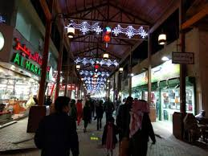
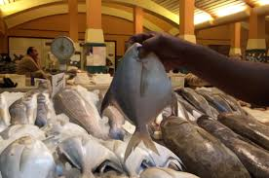
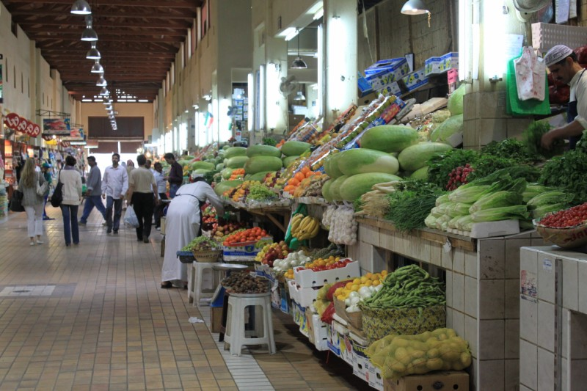
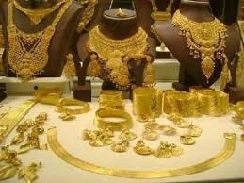
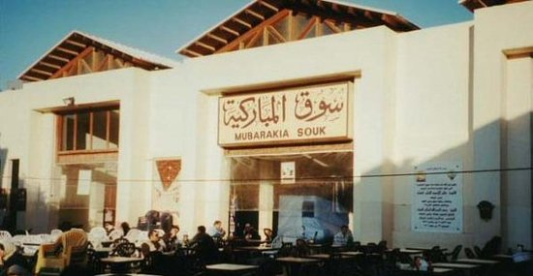
* look at the pictures and write a short paragraph of (5) sentences on (Shopping) by using the following guide words:-
(went – Mubarakiah Souq – yesterday / went – mother / bought – earrings – gold / lettuce – vegetable market / fish – market )
Shopping
…………………………………………………………………………………………………………………………………………………………………………………………………………………………………………………………………………………………………………………………………………………………………………………………………………………………………………………………………………………………………………………………………………………………………………………………………………………………………………………………………………………………………………………………………………………………………………………………………………………….
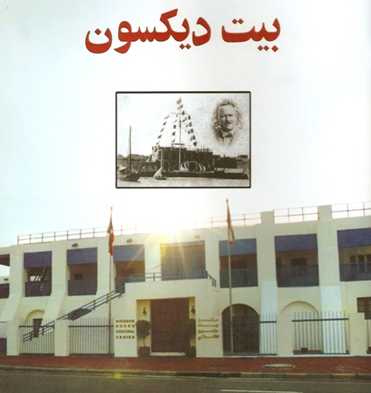
**************************************************************************
* Write a paragraph of (5) sentences on " Dickson House" using the help of the following words:-
old house / sea / family – live / thirty rooms /
became – museum/

Dickson House
………………………………………………………………………………………………………………………………………………………………………………………………………………………………………………………………………………………………………………………………………………………………………………………………………………………………………………………………………………………………………………………………………………………………………………………………………………………………………………………………………………………………………………….
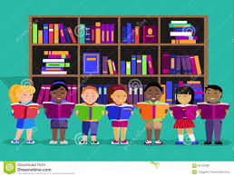
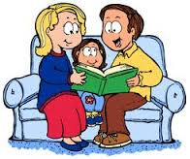
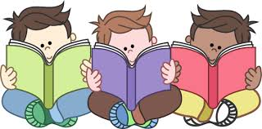
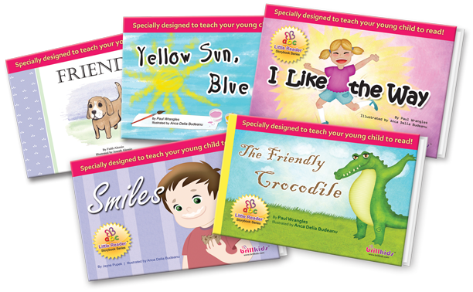
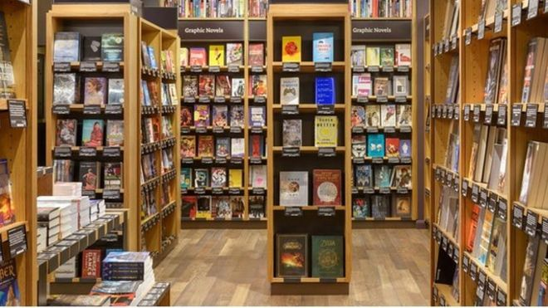
* Write a paragraph of (5) sentences on " Reading " using the help of the following words:-

favourite hobby / like – storybooks / bought – bookshop / read – library / home /
Reading
……………………………………………………………………………………………………………………………………………………………………………………………………………………………………………………………………………………………………………………………………………………………………………………………………………………………………………………………………………………………………………………………………………………………………………………………………………………………………………………………………………………………………………………………………………………………………………………………………………………………………………………………………………………………………………………….
**************************************************************************
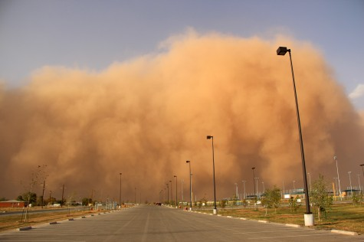
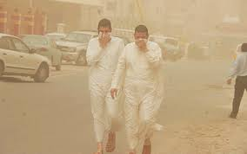
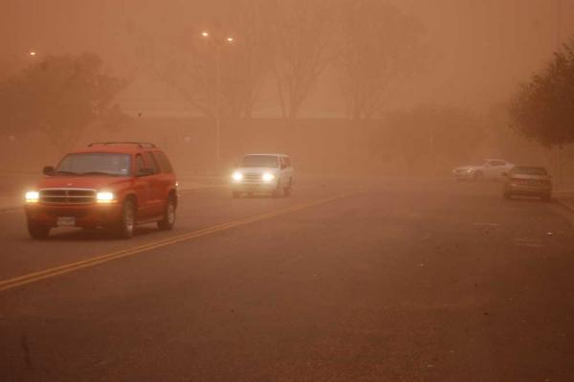
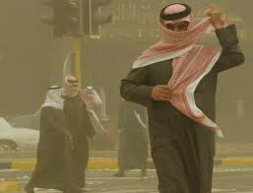
Dust storm

/ dangerous / come – suddenly / cover – mouth – nose / stop – car / not go out /
…………………………………………………………………………………………………………………………………………………………………………………………………………………………………………………………………………………………………………………………………………………………………………………………………………………………………………………………………………………………………………………………………………………………………………………………………………………………………………………………………………………………………………………………………………………………………………………………………………………….

5th Grade Grammar Revision 1st Term مراجعة قواعد خامس الفصل الأول

can – could – will – would – shall – should give – tell – write – read – like
must – mustn't – have to – has to – had to مصدر فعل بدون إضافات
don't – doesn't – didn't – to – let's – might help – eat – sleep – drink – cover

1- I'd like to ( eats – eating – ate – eat ) apples.
2- Could you ( helping – help – helped – helps ) me with my homework, please?
3- They didn't ( have – has – had – having ) electricity in the past.
4- You might ( got – gets – get – getting ) dust in your nose.
******************************************************************
something شيئ ما ) ) تستخدم في الإثبات وليست في النفي. *

1- I want to buy something for Aunt Yasmeen.

anything والاستفهام ( ؟ ) أي شيئ (not) تستخدم في النفي

1- Do you need anything for the party?
2- I don't need anything for the party.
3- Have you got ( anything – something – nothing – someone ) in your bag?
4- Sara bought ( someone – anything – something – somewhere) for Yasmeen.
5- They didn't have ( something – someone – nothing – anything ) to drink.
******************************************************************
I am
He – She – It مفرد - is going to + ( ( فعل بدون إضافات
We – They – You – جمع are

1- I (am going to visit – visit – visited – visiting ) my grandpa tomorrow.
2- Salem is ( phone – phoned - going to phone – phones ) me next week.
3- They are going to (walked – walk – walking – walks) on the beach tomorrow.
The Past Simple Tense زمن الماضي البسيط
yesterday – in the past فعل + d – ed – ied ( phoned – played – cried )
هذه الكلمات يأتي معها
ago – last – once أفعال شاذة ( went – wrote – drove – gave )

1- They ( walk – will walk – walks – walked ) to school yesterday.
2- In the past, people ( have – had – has – will have ) paraffin lamps.
3- My father ( drove – drives – drive – driving ) to the farm last week.

Look! – Listen! – now am
هذه الكلمات يأتي معها is + فعل - ing
at the moment - still are
1- Look! I am climbing the tree. 2- Ali is reading a book now.
3- They are watching TV at the moment.
4- Listen! The baby is ( crying – cry – cries – cried ).
5- They ( cleans – cleaned – are cleaning – clean ) the house now.
6- What are you ( do – does – did – doing ) now?
********************************************************************
at the frontفي المقدمة / next to بجوار / between بين / at the backفي الخلف
********************************************************************

but ((لكن تربط جملتين متناقضتين ( تضاد ) وتأتي في وسط الجملة
1- Sara likes storybooks but she doesn't like scary books.
2- Saad is tall but Faisal is short.

and ( و ) تستخدم لربط جملتين متوافقتين وتأتي في وسط الجملة
1- My mother went shopping and bought some meat.
2- I like drinking fresh juice and milk.
3- Nasser speaks Arabic ( and – but – so – or ) he can't speak French.
4- Dad came back home ( so – or – but – and ) had lunch.
The present Simple Tense زمن المضارع البسيط
He – She – It always – sometimes – often visits – walks – goes - finishes
هذه الكلمات يأتي معها فعل) + s – es – ies )
أي إسم مفرد usually – every – never carries – cries – marries

1- Ahmed always ( gets – get – will get – got ) up early.
2- It never ( snow – snowed – snows – snowing ) in Kuwait.
******************************************************************
too صفة ( too long – too small – too big – too scary – too difficult )

not + صفة + enough not hot enough – not easy enough – short enough

1- This storybook is ( enough – too – to – two ) scary.
2- My car isn't big ( to – too – very – enough ).
Ministry of Education First Term
Religious Education Admin. نموذج اختبار
Sulibikaat Religious Inst. Grade Five

I) Reading ( 12 Marks )

**Read the following passage and answer the following questions:-

It is Friday. The boys are not at school. Ali, Hamad and Nuri are playing football in the field. They are going to play football all the morning. There are twenty-two boys in the field; and they are all playing football. Ali and Nuri are in the same team. But Hamad is in the other team. Hamad's team scores five goals. The other team scores only three goals. Hamad is happy, but Ali and Nuri are unhappy. Hamad says, 'My team has five goals, and we win the game.'

A:-Choose the right answer from a,b,c and d :- (4 ×3=12)
1-The underlined word 'They' in line two refers to the …………………
a- schools b- fields c- goals d- boys
2-The best title for the passage is ………………………
a- A football game b- A holiday c- A football team d- Goals
3- They play football on ………………………
a- Sunday b- Friday c- Monday d- Tuesday
4- Ahmed and Ali are ………………………
a- happy b- unhappy c-beautiful d- fast

A) Choose the correct word from a,b,c and d :- (3x3=9)
1- On hot nights, people slept on the ……………… of the house.
a- stairs b- roof c- souq d- book fair
2- Roads are very…………………..in Canada in winter.
a- heavy b- easy c- poor d- icy
3- There are a lot of books on the shelf. You can……………..your favourite.
a- choose b- wait c- blow d- feel
*********************************************************
B) Choose the correct answer from a,b,c and d :- (3x2=6)
4- I like fruits ………………….I like vegetables.
a- but b- and c- so d- or
5- You might……………………..dust in your mouth in a dust storm.
a- got b- getting c- get d- gets
6- In the past children …………………….in Al-Katateeb.
a- learned b- learns c- learn d- learning

Writing (13 Marks)

A) Look at the picture and write a short paragraph of (5) sentences on
( My favourite hobby) :- (10 Marks )

favourite hobby- reading / like – storybooks / bought – bookshop /read – library /home /
My favourite hobby
………………………………………………………………………………………………………………………………………………………………………………………………………………………………………………………………………………………………………………………………………………………………………………………………………………………………………………………………………………………………………………………………………………………………………………………………………………………………………………………………………………………………………………………………………………………………………………………………………………………………………………………………………………………………………..……
……………………………………………………………………………………………….

B) Fill in the missing letters ( 3Ï1=3)
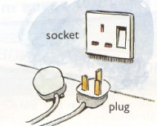
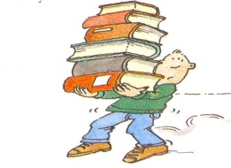
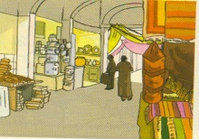

5) el – ctri – ity 6) c – rr – 7) s – u –

Good Luck

